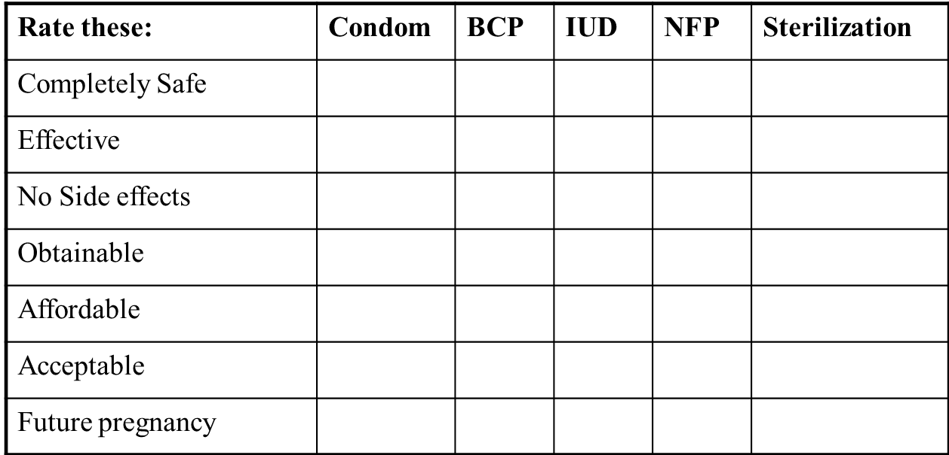

Which family planning

method is the most healthy for you?

Give 1 point for poor, 2 points for satisfactory, or 3 points for good. Total the points at bottom of page.