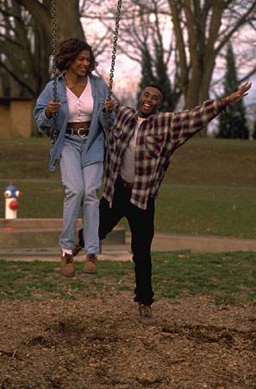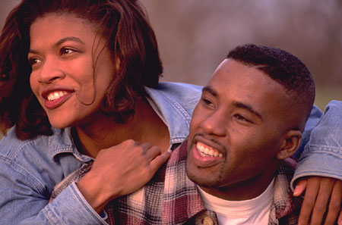

African American Culture

Most African, or “black” Americans” descended from people who were brought to America as slaves from the West coast of Africa many generations ago. There are also many who immigrated to the U.S. voluntarily in more recent years.

Control of their Environment:

Some ”traditional “ people, believe in folk medicine and traditional healers

Biological Differences:

Increased risk for sickle cell anemia, hypertension, cancer of the esophagus or stomach, and lactose intolerance

Social Organization:

Family has many single parent, female-headed households with large, extended family networks
If father is not present, families have few positive male role models
Strong church affiliations and community social organizations
Early childbearing with kin-centered child-raising in multigenerational families is common

Communication: Use English Language. Old national languages or dialects may have been Pidgin, French, Spanish, or Creole.

Space: Close personal space

Time Orientation:

Focus is on the present over future. Although they may be concerned about their health, they don’t typically look to the future, and may not keep follow-up appointments

Cultural beliefs, norms, and practices:

- Health beliefs include:
  - Health is achieved when in harmony with nature, and illness occurs when in disharmony.
  - Health includes mind, body and spirit
  - Power to influence destiny is possible through behavior and knowledge
  - Health is maintained with rest, clean environment, and proper diet- three meals a day
  - Some use folk healers, voodoo, “rooting”, or other home remedies
- Values caring presence, physical touching, and being involved with family and community
- Extended family helpful for daily survival if living in poverty, but may cause crowded living conditions
- Traditional foods include hearty meals and “soul food”
- Religion is valued (many are Baptists). Worship is with prayers and songs
- Technology, music, and physical activity (like sports) are valued
- Elderly are held in high esteem because of wisdom and knowledge. Younger family members care for them
- Verbal expressions, and expressions of pain can be quite open

Culturally Congruent Care:

- Use direct eye contact, and respectful, informal conversations
- Trust is built through listening to patient, overcoming any feeling of racism or powerlessness by explaining things so they understand.
- Communication and relationships are the key to whether the patient will share significant complaints and whether they will return for care
- Set short-term goals with the patient
- Disagreements with health professionals often result in noncompliance
- African American patients often come late, or miss medical appointments. They prefer walk-in clinics where waits are shorter, or traditional folk healers
- Family responsibilities come before all other responsibilities
- May need health care provides to recognize and assist if domestic violence related to alcohol abuse occurs
- Uphold cultural rituals and practices whenever possible

References:

Giger, J.N. & Davidhizar, R.E. (1995). Transcultural nursing assessment and intervention (2nd ed.). St. Louis: Mosby.
Julia, M. C. (1996). African American health care: Beliefs, practices, and service issues. In Multicultural awareness in the health care professions (pp. 8-19). Boston: Allyn & Bacon.

Leininger, M. (1991). Culture care diversity and universality: A theory of nursing (p. 361). New York: NSN Press.

Leininger, M. (2002). South African culturally based health-illness patterns and humanistic care practices. In Transcultural nursing: Concepts, theories, research, and practice (3rd Ed., pp. 325-332). New York: McGraw-Hill.

Spector, R.E. (1996). Health and illness in African (Black) American communities. In S.J. Garhydt & S. Greenfield (Eds.) Cultural diversity in health and illness. (pp.191-210). Stamford, CT: Appleton & Lange.

Spector, R.E. (1996). Cultural phenomena affecting health. In S. J. Barhydt & S. Greenfield (Eds.), Guide to heritage assessment and health traditions. (pp. 6-10). Stamford, CT: Appleton & Lange.

