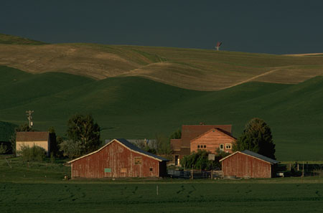

# Amish Culture

The Amish are a socio-religious group that separated from the Mennonites, or Swiss Anabaptist (a group which practiced adult baptisms) and migrated to North America in the 1700s and 1800s. Amish settlements were small, isolated and scattered. Today, the majority of Amish groups are affiliated with four orders-Old Order, New Order, Andy Weaver, and Swartzentruber. They operate independently from each other with variations on how they interpret the Bible, how they dress, and how they conduct their daily lives. Amish are sometimes referred to as “plain people” because of their modest clothing and simple ways.

**Control of Environment:**

Traditional health and illness beliefs continue, such as folk medicine and traditional healers

**Biological Differences:**

Increased risk of birth defects, mental disorders, accidents and injuries

**Social Organization:**

Strong reliance on large families, and extended family networks, with multigenerational farms, and cohesive church community

Congregations organized into church districts. Worship services may be conducted in homes rather than churches

Bishop, as spiritual head of the church district, interprets and monitors church doctrine and solves disputes with the help of ministers

“Ordnung” is a set of oral rules for living.

* Technology and farm practices may be different between church districts
* Electricity is not found in homes, but generators or natural gas may be used in some church districts
* Telephones and refrigerators may be found in a few communal buildings
* Amish do not own automobiles, and they use horses and buggies for transportation
* Farm work is usually done with horses

Father or oldest male in the family holds the greatest power and may make health decisions for others in the family

Women are respected for their opinion and make some decisions for the home and family. Married women usually work at home.

Children are educated to the eighth grade, usually in private, one-room schoolhouses. Some progressive Amish do attend high school and college.

Adolescents have a chance to explore and experience the world before they are baptized

Young adults usually work and contribute their income to their family

Most Amish view the government with distrust, and do not agree with all its laws. They do not become involved in lawsuits

The elderly are well-respected and considered important advisors

**Communication:**

German is the primary language, but most are multilingual

**Space:**

Allow physical space when talking, and avoid touching, especially opposite genders

**Time Orientation:**

Focus is on the present. They don’t typically look to the future, and may not keep follow-up appointments. However they do have aspects of future orientation by participation in research, prenatal care, and immunization of their children

**Cultural beliefs, norms, and practices:**

* Health beliefs include:
  + Health is “having a good appetite”, and the ability to work hard
  + Illness is defined not by symptoms, but by inability to perform daily functions or work
  + Medical doctors are not usually consulted until they are very uncomfortable or sick
  + They are permitted to use modern facilities and treatments
  + The Amish community usually pays for medical care because they don’t utilize health insurance
  + Folk healers, chiropractors, massage therapists may be consulted, or herbs, charms, and home remedies are used for illness
* Work is seen as good and meaningful. Some work is done in small groups that turn into a celebration, like a barn raising
* Amish do not usually use alcohol, tobacco, or drugs other than for medicinal purposes
* Traditional foods are balanced and healthy, usually homegrown
* Amish people are Christians. Spiritual and religious influence play a major part in day-to-day life

**Culturally Congruent Care:**

* Be genuine in face-to-face relationships with Amish patients. Use basic language, without technical language or jargon
* Offer choices in plan of care, and discuss the cost of options, perhaps in consultation with other family members and the bishop
* Trust is important to whether they will return for care
* Direct disagreement with a health professional would be uncommon; the usual response would be silence and noncompliance
* Set short-term goals with the patient
* Recognize the male dominance of Amish society, and approach an Amish family through the father, or approach the community through a bishop
* Evaluate alleged child abuse and neglect within the cultural context of Amish childrearing practices
* Discuss birth control or genetic screening with caution
* Family responsibilities come before all other responsibilities
* Respect the wishes of the family and uphold cultural rituals and practices whenever possible

**References:**

Giger, J.N. & Davidhizar, R.E. (1995). Transcultural nursing assessment and intervention (2nd ed.). St. Louis: Mosby.

Julia, M. C. (1996). Amish health care beliefs and practices. In Multicultural awareness in the health care professions (pp. 23-38). Boston: Allyn & Bacon.

Strouse, S. & James, B. Working with the Amish. Retrieved September 19, 2004, from Ohio State University Extension Web site: <http://ohioline.osu.edu/hyg-fact/5000/5236.html>