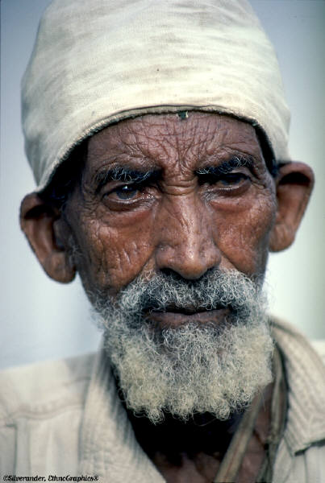

Arab Culture

The term “Arab Americans” refers to people who were born in or whose ancestors came from twenty-two Arab countries, including Egypt, Iraq, Jordon, Lebanon, Saudi Arabia, Palestine, Syria, Sudan, and Yemen, who now live in the United States. Although most Arab people are Muslim, there are also many Christian Arabs.

Control of Environment:

Traditional health and illness beliefs may continue to be observed, including belief in predestination-that God has ultimate control over all that happens

Biological Differences:

Increased risk for diabetes mellitus and hypertension

Social Organization:

Religion is a major factor of social structure for Arab Muslims, providing cultural rules that guide family living and influence care practices.
Male is head of household, but strong reliance on extended family and kinship ties
Arab Muslims are expected to place priority on family or group concerns, not individual
Children are regarded as God’s greatest gift
Elderly are treated with respect, and usually live with oldest son
Women are expected to consult their husbands for health decisions, (except some couples choose not to discuss sensitive sexual matters, like family planning)

Communication:

Arabic is the primary languages. Language barriers are common

Space:

Respect modesty of women (less direct eye contact)

Time Orientation:

Focus is on the present. Although they are concerned about their health, they don’t typically plan ahead. There is a tendency to have leisurely pace, and be late for appointments

Cultural beliefs, norms, and practices:

- Health beliefs include:
  - Following the teaching of the Koran
  - “A person is healthy if he or she is in harmony with God”
  - Illness occurs when supernatural forces such as evil take over
  - God has the ultimate power to cure
  - Illness could be considered punishment
  - Preventative rituals are used, such as praying, the use of amulets or religious relics, herbs, and fumigations to ward off disease
  - “Evil Eye” caused by looking with admiration or jealousy at another person
- Folk healers or religious healers are used for some illnesses
- Western medicine is highly valued. When seeking medical care, may have an exaggerated respect for power of physician and defer decision-making
- Preventive care is not usually sought
- Visiting of the sick is a social obligation, especially during hospitalization
- Eating balanced meals prevents disease and promotes health
  - Islamic religion prohibts consumption of alcohol and pork
  - Arab Muslims are wary of ingredients and the origins of medications
- Death may be accompanied by loud wailing, crying, and moaning of female family members, including tearing of hair and clothes
- Spiritual and religious influence play a major part in day-to-day life
  - Pause to pray to Allah five times a day

Culturally Congruent Care:

- Offer privacy and respect for religious beliefs and prayer. Do not interrupt during prayer time at dawn, noon, midafternoon, sunset, and dusk
- Anticipate large numbers of visitors during illnesses. Provide comfortable accommodations, if possible. Value family care and support practices
- Allow women to choose female physician, if possible, and protect modesty as much as possible
- Allow women to consult their husband or a male family member for decision-making
- Greet Arab Americans with pleasantries to build familiarity prior to sharing their thoughts
- Help to “save face” by preserving dignity and honor
- Set short term goals with patient
- When disagreeing with a health professional, they may hint at their disagreement, or simply fail to follow through
- Avoid discussing a terminal diagnosis with traditional Arab Muslims, or provide some hope of recovery- “To speak of death is to bring it about.”
- Understand that Arab patients often come late, or miss medical appointments.
- Uphold cultural rituals and practices whenever possible
  - Know cultural taboos, such as no pork, alcohol
  - Provide diet compatible with Islamic diet

References:

Giger, J.N. & Davidhizar, R.E. (1995). Transcultural nursing assessment and intervention (2nd ed.). St. Louis: Mosby.

Julia, M. C. (1996). Arab Americans. In Multicultural awareness in the health care professions (pp. 60-73). Boston: Allyn & Bacon.

Leininger, M. (1991). Culture care diversity and universality: A theory of nursing (p. 361). New York: NSN Press.

Leininger, M. (2002). Arab Muslims and Culture care. In Transcultural nursing: Concepts, theories, research, and practice (3rd Ed., pp. 301-309). New York: McGraw-Hill.

