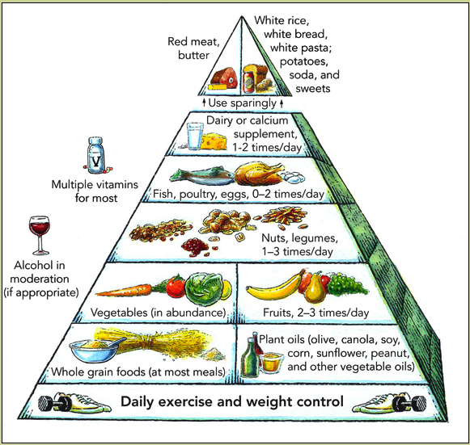

Although this is not the most current nutrition guideline, it is still a good reference. Copyright © 2008 Harvard University. For more information about The Healthy Eating Pyramid, please see The Nutrition Source, Department of Nutrition, Harvard School of Public Health, http://www.thenutritionsource.org, and Eat, Drink, and Be Healthy, by Walter C. Willett, M.D. and Patrick J. Skerrett (2005), Free Press/Simon & Schuster Inc.

See further description of the Healthy Eating Pyramid at http://www.hsph.harvard.edu/nutritionsource/what-should-you-eat/pyramid/index.html.

