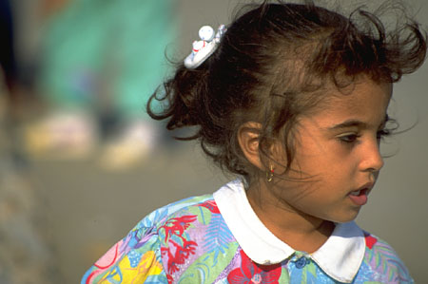

Hispanic Culture

The term “Hispanic Americans” refers to people who were born in or whose ancestors came from Mexico, Puerto Rico, Cuba, Central and South America, Spain, and other Spanish-speaking communities, who now live in the United States. They may refer to themselves as Mexican American, Spanish American, Latin American, Latin, Latino, Mexican, or Chicano.

Control of Environment:

Traditional health and illness beliefs continue, such as folk medicine and traditional healers

Biological Differences:

Increased risk for diabetes mellitus, parasites, coccidioidmycosis, lactose intolerance

Social Organization:

Strong reliance on nuclear families with large, extended family networks, including godparents
Strong church affiliations and community social organizations
Father or oldest male in the family holds the greatest power and may make health decisions for others in the family
Publicly, women are expected to show respect and submission to their husbands

Communication:

Spanish or Portuguese are the primary languages. Language barriers are common
Space:

Tactile relationships, like touch, handshakes, embrace, and physical presence are valued

Time Orientation:

Focus is on the present. Although they are concerned about their health, they don’t typically look to the future, and may not keep follow-up appointments

Cultural beliefs, norms, and practices:

- Health beliefs include:
  - Hispanic “Hot” and “cold” conditions are treated to bring their health back in balance and harmony
  - Natural and supernatural worlds are not clearly distinguishable
  - Illness could be considered punishment for transgressions, or sick people could be considered innocent victims of “fate” with little responsibility to take action to regain health
  - Hispanics may have dramatic outbursts of emotion. Moaning is a way to reduce pain and to share it with others
  - Susto is “soul loss”, which may be acute or chronic
  - Mal de Ojo is the “Evil Eye” caused by looking with admiration or jealousy at another person
  - Folk healers, herbalists, and home remedies are used for illness
- Traditional foods include rice, beans, and tortillas, usually prepared with lard
- Most Hispanics are Roman Catholic. Spiritual and religious influence play a major part in day-to-day life
  - Candles, medals, and pictures of saints are often used

Culturally Congruent Care:

- Use less direct eye contact, with respectful and warm, but formal conversations
- Trust is critical. Communication and relationship are the key to whether the patient will share significant complaints and whether they will return for care
- Direct disagreement with a health professional would be uncommon; the usual response would be silence and noncompliance
- Set short-term goals with patient
- Hispanic patients often come late, or miss medical appointments. They prefer walk-in clinics where waits are shorter, or traditional folk healers
- Family responsibilities come before all other responsibilities
- Uphold cultural rituals and practices whenever possible

References:

Giger, J.N. & Davidhizar, R.E. (1995). Transcultural nursing assessment and intervention (2nd ed.). St. Louis: Mosby.

Julia, M. C. (1996). Understanding the Hispanic community. In Multicultural awareness in the health care professions (pp. 111-129). Boston: Allyn & Bacon.

Leininger, M. (1991). Culture care diversity and universality: A theory of nursing (p. 356). New York: NSN Press.

Leininger, M. (2002). Culture care of the Mexican American family. In Transcultural nursing: Concepts, theories, research, and practice (3rd Ed., pp. 363-371). New York: McGraw-Hill.

Spector, R.E. (1996). Health and illness in Hispanic American communities. In S.J. Garhydt & S. Greenfield (Eds.) Cultural diversity in health and illness. (pp.279-304). Stamford, CT: Appleton & Lange.

Spector, R.E. (1996). Cultural phenomena affecting health. In S. J. Barhydt & S. Greenfield (Eds.), Guide to heritage assessment and health traditions. (pp. 6-10). Stamford, CT: Appleton & Lange.

