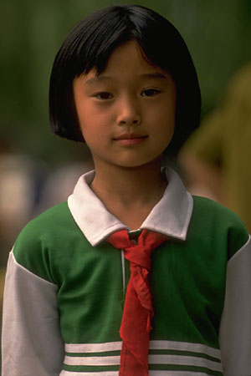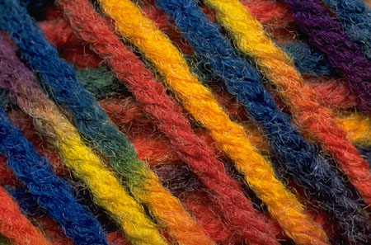

Hmong Culture

The Southeast Asian Americans mostly came as refugees to the United States. They are mostly Vietnamese, ethnic Chinese, Cambodians (Khmer), Laotians, and Hmong. Since their arrival, Southeast Asians have resettled throughout the United States, and there continues to be migration from state to state, as well as more immigration of refugees.
Hmong originally migrated from Siberia to northern China, but were at war after they refused to embrace Chinese culture. They became migrants for many years. They settled in high-altitude mountain regions of Southeast Asia, for many generations of relative peace and prosperity.
When political unrest occurred, many people died due to political involvement with U.S. Thousands left their homeland for the west, at the end of the 1975 civil war.

Control of Environment:

Traditional health and illness beliefs continue, such as folk medicine and traditional healers

Biological Differences:

Southeast Asian Americans have risk for anemias, lactose intolerance, and infections diseases among overcrowded refugees

Social Organization:

- Hmong people have strong ethnic identity, social unity, and close family ties
- Hmong clans recruit new members mostly through marriages. Women may not marry someone with the same last name (since they are from her clan)
- Women do not change their name when married, but it is acceptable to say either her last name, or her husband’s last name
- Newlywed couples usually reside with the groom’s family
- Widowed women may marry a brother of her late husband
- Property and resources may be pooled under control of the clan leaders
- Community social structures have power, keeping people together to maintain cultural roots
- Strong reliance on close families with large, extended family networks
- Father or oldest male in the family may make health decisions for others in the family, but clan leaders have the ultimate decision

Communication: Hmong is the primary language. Language barriers are common, but children are usually bilingual

Space: Hmong people are happy and hospitable. They do not feel comfortable with direct eye contact.

Time Orientation:

Focus is on the present. They don’t typically look to the future for health care, and may not keep follow-up appointments

Cultural beliefs, norms, and practices:

- Health beliefs include:
  - Health and illness result from the relationship between the person and elements in the universe.
  - Religious beliefs (animism) and health practices combine natural and supernatural worlds
  - Illness is from soul loss, witchcraft, and evil spirit possession
  - Folk healer, called a shaman is believed to have healing power from the gods
  - Amulets, charms, knotted strings, special cloths, massage, herbal preparations, “cupping”, or “coining” of skin are some folk remedies
- Traditional foods include home grown vegetables, fresh meat, and few sweets. Children may request “American food”
- After giving birth, traditional women follow a diet of chicken, rice, and hot water for 30 days

Culturally Congruent Care:

- Prefers less direct eye contact. Respectful and warm formal conversations help build trust
- Communication and relationship are the key to whether the patient will share significant complaints and whether they will return for care
- Direct disagreement with a health professional would be uncommon; the usual response would be silence and then not cooperating
- When listening to health professionals, they will frequently nod and say, “yes”. Keep in mind that it means, “yes, I am listening to you,” not “yes, I understand,” or “yes, I agree.”
- Health decisions are made by the head of household, and/or elders of the clan
- Hmong people often come late, or miss appointments. They prefer walk-in clinics where waits are shorter, or traditional folk healers
- Family responsibilities come before all other responsibilities
- Uphold cultural rituals and practices whenever possible

References:

Betancourt, D. Cultural diversity: Eating in America-Hmong. Retrieved September 19, 2004, from Ohio State University Extension Web site: http://ohioline.osu.edu/hyg-fact/5000/5254.html

Giger, J.N. & Davidhizar, R.E. (1995). Transcultural nursing assessment and intervention (2nd ed.). St. Louis: Mosby.

Julia, M. C. (1996). Asian Americans. In Multicultural awareness in the health care professions (pp. 77-105). Boston: Allyn & Bacon.

