# 

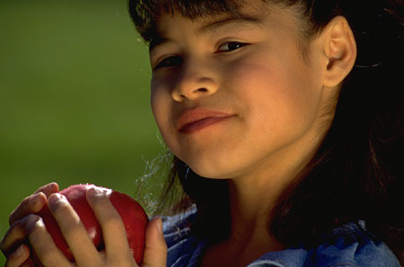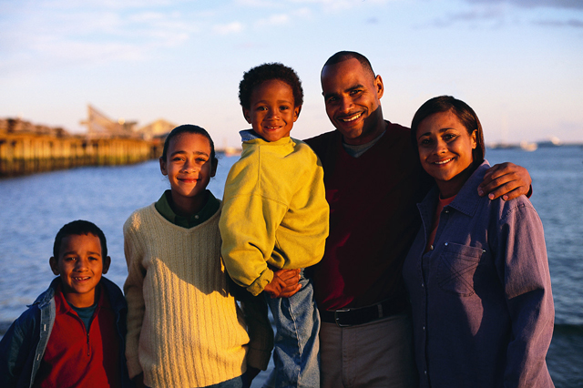

# **Native American Culture**

The term “Native Americans” refers to people who were are descendents of the original inhabitants of the North American continent. This diverse group comprises numerous tribes and over 400 federally recognized nations, each with its own traditions and cultural heritage. Eskimos, Aleuts, and Indians residing in Alaska are referred to as Alaska Natives and those residing in other states are referred to as American Indians.

**Control of Environment:**

Traditional health and illness beliefs continue to be observed by “traditional” people, such as natural and magicoreligious folk medicine and traditional healers

**Biological Differences:**

Increased risk for accidents, heart disease, cirrhosis of the liver, and diabetes mellitus

**Social Organization:**

Extremely family-oriented to both biological and extended families

Children are taught to respect tradition

Strong community social organizations

Father or oldest male in the family holds the greatest power and may make health decisions for others in the family

Tribal elders are highly respected in their Indian “Nation”

**Communication:**

Tribal languages. Also use silence and body language

**Space:**

Space very important, and has no boundaries

**Time Orientation:**

Focus is on the present. They don’t typically look to the future, and may not keep follow-up appointments

**Cultural beliefs, norms, and practices:**

* Health beliefs include:
  + Wise ones (elders, medicine people, and “singers”) can and will pass knowledge and sacred practices down from generation to generation
    - All things in life are connected, circular, and rhythmic with nature
    - Energy of the body is divided into positive and negative, controlled by spiritual means
    - Religion, customs and beliefs vary widely among subgroups, but there is a belief in the Great Mystery/Spirit/Creator and a personal commitment to the “Source of Life”
    - Harmony between land, people, and environment is valued
    - Natural and supernatural worlds are not clearly distinguishable
    - Illness could be considered a price to be paid for something that happened in the past or for something in the future.
* Native Americans tend to be stoic with lack of expression, unless they are familiar with the other person
* Honesty is valued.
* They do not write down their cultural stories or beliefs
* Tribal religious practices, stories or traditional medicine practices are not shared unless trust is built
* Folk healers, shamans, or medicine people use herbs and roots for some health problems, but modern medicine is accepted and readily used
* Traditional, healthy native foods may not be available. Lower quality diet combined with alcoholism and obesity increase health risks
* Spiritual and religious influence play a major part in day-to-day life, giving back to “Mother Earth”
  + Tobacco, peace pipes, and “medicine bundles” incense are often used in addition to traditional dances and ceremonies

**Culturally Congruent Care:**

* Understand nonverbal behavior in a respectful, formal way. Try not to take notes during conversation
* Speak to patients in a quiet setting where their low tone of voice may be heard
* Trust is critical. Communication and relationship are the key to whether the patient will share significant complaints and whether they will return for care
* Direct disagreement with a health professional would be uncommon; the usual response would be silence and noncompliance
* Set short-term goals with patient
* Native American patients often come late, or miss medical appointments. They prefer walk-in clinics where waits are shorter, or traditional folk healers
* Recognize and assist when domestic violence related to alcohol abuse occurs
* Uphold cultural rituals and practices whenever possible

**References:**

Giger, J.N. & Davidhizar, R.E. (1995). Transcultural nursing assessment and intervention (2nd ed.). St. Louis: Mosby.

Julia, M. C., (1996). Health care provision and Native Americans. In Multicultural awareness in the health care professions (pp. 146-161). Boston: Allyn & Bacon.

Leininger, M. (1991). Culture care diversity and universality: A theory of nursing. (p. 361). New York: NSN Press.

Leininger, M. (2002). Transcultural Nursing and health care among Native American peoples. In Transcultural nursing: Concepts, theories, research, and practice (3rd Ed., pp. 429-439). New York: McGraw-Hill.

Spector, R.E. (1996). Health and iIllness in the American Indian, Aleut, and Eskimo communities. In S.J. Garhydt & S. Greenfield (Eds.) Cultural diversity in health and illness (pp.215-237). Stamford, CT: Appleton & Lange.

Spector, R.E. (1996). Cultural phenomena affecting health. In S. J. Barhydt & S. Greenfield (Eds.), Guide to heritage assessment and health traditions (pp. 6-10). Stamford, CT: Appleton & Lange.