(Print these out, cut them out and attach to cards. On the other side of the card, put the amount of money it is worth. The category they belong to is listed with each Jeopardy answer/question.)

Tracheostomy:
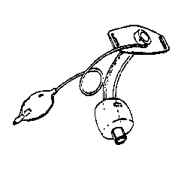
What is a cuffed trach tube?

Tracheostomy:
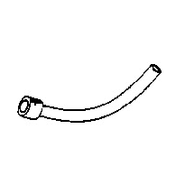
What is the inner cannula of the trach tube?

Tracheostomy:
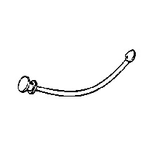
What is the obturator for the trach tube?

Tracheostomy:

Routine cleaning, skin care, inspection and dressing change

What is tracheostomy care every 8 hours?

Tracheostomy:

Keep an extra one at the bedside or taped to the head of the bed

What precaution for patient safety is done with a tracheostomy tube and obturator?

Tracheostomy:

Correct tightness of trach ties or collar

What are trach ties that feel tight with one finger inserted underneath?

Tracheostomy:

Fenustrated trach tube, deflated cuffed trach, or cuffless trach with Passey Muir valve

What are trach tubes that allow speech?

Oxygen Administration:

Oxygen saturation (Pa0₂) of 88% or less

What is a sign of hypoxia based on pulse oximetry?

Oxygen Administration:

Inline humidifier attachment

What adds humidity to oxygen or air by bubbling gases through sterile water?

Oxygen Administration:

Only up to 2-3 L/min. flow rate

What is the typical maximum oxygen flow rate prescribed for patients with chronic lung disease?

Oxygen Administration:

Only up to 6 L/min because of nasal dryness, irritation, and gastric distension

What is the maximum liter flow to be delivered through a nasal cannula?

Oxygen Administration:

At 4-10 L/min, it can deliver 24-55% FiO₂ (by adjusting its dial)

What is a Venturi mask?

Oxygen Administration:

At 6-15 L/min, it can deliver 60-100% O₂

What is a non-rebreather mask?

Oxygen Administration:

100% O₂ saturation consistently while oxygen is being administered

What is a sign that oxygen may be too high and should be gradually decreased?
Suctioning:

Motion of the catheter while suctioning to decrease trauma to respiratory tract

What is intermittent suction, rotating while the catheter is being pulled out?

Suctioning:

Size 8-10 French with 5-10 mm Hg

What is typical catheter size and vacuum pressure for a child with portable suction machine?

Suctioning:

Only 10-15 seconds of intermittent suction

What is the maximum respiratory suction time to avoid hypoxia?

Suctioning:

Size 8-10 Fr. using 50 mm Hg

What is the typical suction catheter size and vacuum pressure for a newborn?

Suctioning:

Prepare for this procedure by giving oxygenated breaths with Ambu bag

What can be done prior to suctioning to hyper-oxygenate a patient with a trach?

Suctioning:

Size 12-16 French with 100-120 mm Hg

What is the typical suction catheter size and vacuum pressure setting for adults?
Suctioning:

Trachojets or nebulizer treatment with normal saline

What is often helpful for ineffective suctioning of thick secretions?

Miscellaneous:

A closed drainage system with a container that is closely observed, but never emptied

What is removing air or fluid with a chest tube?

Miscellaneous:

Confusion, anxiety, and rapid, shallow respirations

What are some possible subtle signs of hypoxia?

Miscellaneous:

Inhaled medications used to open narrowed airways

What are bronchodilators?

Miscellaneous:

Using a mouthpiece or mask with a cup to distribute aerosolized medication for inhalation

What are nebulizer treatments?

Miscellaneous:

Drugs that facilitate removal of respiratory secretions by reducing their thickness

What are expectorants?

Miscellaneous:

The dressing on a chest tube site

What is an occlusive dressing that must provide an airtight seal?

Miscellaneous:
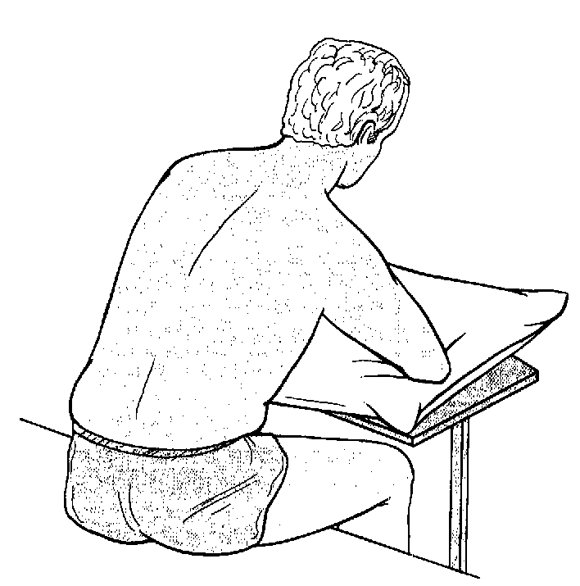

What is the best position of a patient when preparing for thoracentesis?

Patient Teaching:

Exhaling slowly and evenly while positioning lips like whistling or sucking on a straw

What is pursed lip breathing?

Patient Teaching:

Over 60 breaths per minute in an inactive infant, cyanosis, dyspnea, or retractions

What signs of infant respiratory distress should be reported to physician promptly?

Patient Teaching:

It is a sterile procedure at the hospital, but a clean procedure at home

What are the usual home discharge instructions for suctioning?

Patient Teaching:

16-20 breaths per minute without periods of apnea

What is normal breathing in an adult?

Patient Teaching:

Delay this procedure for 1-2 hours after meals

What is the best time for postural drainage to be scheduled?

Patient Teaching:

Safe storage of oxygen tanks

What is strapped on to a wheeled carrier or laying flat on the floor?

Patient Teaching:

Surgical patients should have this prior to effective coughing and deep breathing

What is providing medications for pain, and a reminder to splint incisions?

Critical Thinking:

Using plastic bibs for children with trach or other artificial airway inserted

What is a safety hazard due to possible airway obstruction?

Critical Thinking:

Sudden onset of fever, chills, cough and pleuritic chest pain

What are signs of acute pneumonia?

Critical Thinking:

Bloody secretions, increased cyanosis, excessively fast or slow heart rate

What are some reasons to stop suctioning and notify the physician

Critical Thinking:

Suction catheter size for very small adult or very large child

What are examples of when measuring for suction catheter size is necessary

Critical Thinking:

Bright lights, fingernail polish, hypotension, vasoconstriction, or low hemoglobin

What can give false pulse oximetry readings?

Critical Thinking:

Increased risk of this complication with cuffed trach or ET Tube because of oral or gastric secretions entering trachea

What is Aspiration Pneumonia?

Critical Thinking:

This should be drained from oxygen tubing and ventilation lines if blocking airflow

What should be done with condensation in respiratory tubing from added humidity?

