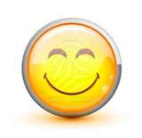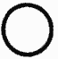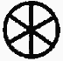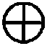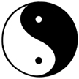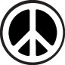
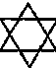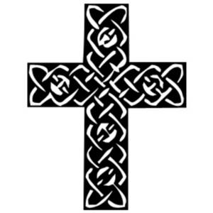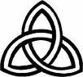

Match the symbols to their names and discuss their meaning:
Happy Face
Circle of Life or infinity
Medicine Wheel, sun wheel, or wheel of life
Sacred Circle to spirits of Earth
Tao symbol – Yin Yang
Peace Sign
Star of David, hexagram or six-pointed star
Celtic Cross
Celtic Trinity
Other symbols of spirituality may include nature, or other ___________________

