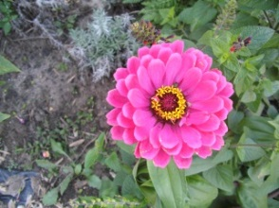
Mark the strengths that you have. Put a star by one or more strengths you want to improve on. Share this list with your health care team.
- Curiosity, or love of learning
- Persistence, or continuing in spite of obstacles
- Kindness, or love
- Social intelligence, or being aware of your feelings and feelings of others
- Fairness, or treating people with respect and justice
- Humility, or modesty
- Self-control of actions, appetites, emotions
- Appreciation of beauty and excellence
- Gratitude
- Hopefulness, or having a positive attitude
- Able to adapt, be flexible or tolerant
- Able to cope well
- Able to express emotions well
- Able to express needs well
- Assertive
- Capable
- Courageous
- Creative
- Energetic or active
- Having faith or spirituality
- Future or goal oriented
- Being a good citizen or team player
- Good sense of humor
- Honest or sincere
- Intelligent or wise
- Motivated
- Open-minded
- Polite or kind
- Realistic or practical
- Resilient
- Resourceful
- Responsible or trustworthy
- Self-reliant or independent
- Sensitive or understanding
- Strong or tough
- Strong support system
- Thoughtful or careful
- Zest for life, spunky, or enthusiastic
Strength-based Recovery
- Strength-based practices promote resilience and self-acceptance for recovery and empowerment
- Challenges situations that may seem hopeless or helpless and doesn’t label people or tolerate stigma
- Builds hope from within, looking at past successes and promoting change by asking:

- What has worked before?

- What has not worked?

- Remember that you are unique – Your strengths and weaknesses are not the same as anyone else’s strengths and weaknesses.
- By getting help and looking at your strengths, a realistic, specific plan can be made to work for you and your situation.

